SUPPORT DOCUMENT

FOR

REUSABLE CUSTOM PIPES IN ANGULAR

This is an Angular application which explains about pipes, their types and in detail about custom defines pipes with two examples which can be reused in any angular project.

This is a web application consists of two pages in which first page contains description about pipes and second page contains how to implement pipes and implemented examples with code.

This implemented pipes as examples are reusable and user can simply copy and paste them in their project by following the steps mentioned in application.

**Benefits of this Asset:**

User gets benefit of learning about functionality of pipes in angular and how are pipes can be defined and used as well. User can learn in depth about custom defined pipes: How user can define and use their own custom defined pipes as per their requirement by following the steps mentioned in the asset.

There were two example pipes used in this assets user can use those pipes in their project by following the steps mentioned in the asset.

**Prerequisites to run the application:**

It’s an angular application which runs on node js, so we need to have node JS installed in your system.

You need to have node modules present in your application folder.

Install by using command: **npm install**

You need to have angular frame work installed.

Install it by using command: **npm install -g @angular/cli**

Used material ui as styling framework for styling the application so you need to have material ui installed in modules.

Install it by using command: **ng add @angular/material**

After installing all required apps you need to serve the application to run it.

Run it by using command: **ng serve**.

By default application will serve at <http://localhost:4200>

**Application explains about:**

Pipes in angular … what are pipes and types of pipes but mainly focuses on custom defines pipes how can user define his/her own pipe and use it across the application and it also contains two pipes as examples which are reusable and user can simply copy and paste them in their project by following the steps mentioned in application.

**What are pipes in Angular:**

Pipes are simple functions to use in template expressions to accept an input value and return a transformed value. Pipes are useful because you can use them throughout your application, while only declaring each pipe once. Technically, pipes are simple functions designed to accept an input value, process, and return a transformed value as the output

**Types of Pipes:**

Pipes in Angular are of two types:

1. Built-in Pipes
2. Custom defined Pipes

**1. Built-in Pipes**

The built-in pipes are those which are already given to us by the Angular and are ready to use. Syntax to use built-in pipes:

<h1>The name of the product is {{ apple | uppercase }}</h1>

In the above code snippet ‘|’ is used to mention pipes, left side of | contains data which needs to be transformed using the pipe. We will learn in depth about custom defined pipes in angular.

**2. Custom defines Pipes:**

The built-in pipes may not be sufficient to fulfill all our use cases. In such situations, we create our own pipes, known as custom pipes. we can use custom pipe in template expressions, the same way we use built-in pipes. This pipes are made according to the requirements of user to satisfy their needs.

How to implement custom defined pipes:

custom pipes can be generated by using Angular cli command

'ng generate pipe pipe-name'.

It contains '@pipe' decorator where name of pipe is mentioned and we should use that pipe name where ever we need to use the pipe.

That pipe should be imported to angular module so that it can be used cross the project templates.

In second page of application you find you input with custom defines pipes used. User can play around.

There are two custom defined pipes used as example:

1.Signed or unsigned decimal:

This pipe will identifies that given number is accepted or not. Accepted number is signed or unsigned decimal or integer numbers it won’t accept any alpha characters or special symbols except '+' or '-' that too at the beginning of the input.

If user enters any unaccepted chars below the field it will be shown as 'Not a signed decimal number' highlighted in red color.

2.first 5 characters pipe:

It is a custom defined pipe which transforms data to fixed length i.e. no matter how much length user give it will slice it to 5 chars length only.

**About application**

This application contains two different components.

Components to refer

Description component

This component basically contains what is pipe, types and definitions

Custom pipes component

This component contains how to create a custom pipe with code example and also a custom defined pipe used fields to play around.

Snapshots of application are provided in the next page…

Application basically lands on description component by default:

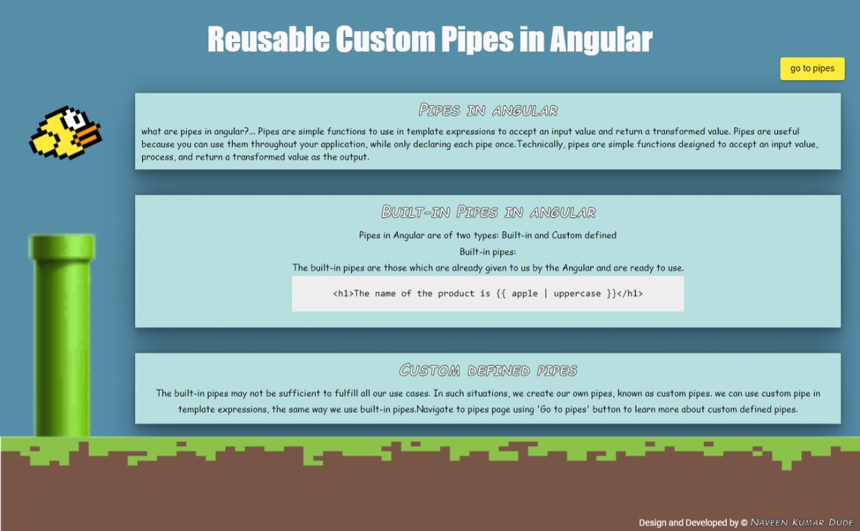

we can navigate by using ‘Go to pipes’ button and navigate back by using ‘Go Home’ button in the header of the page.

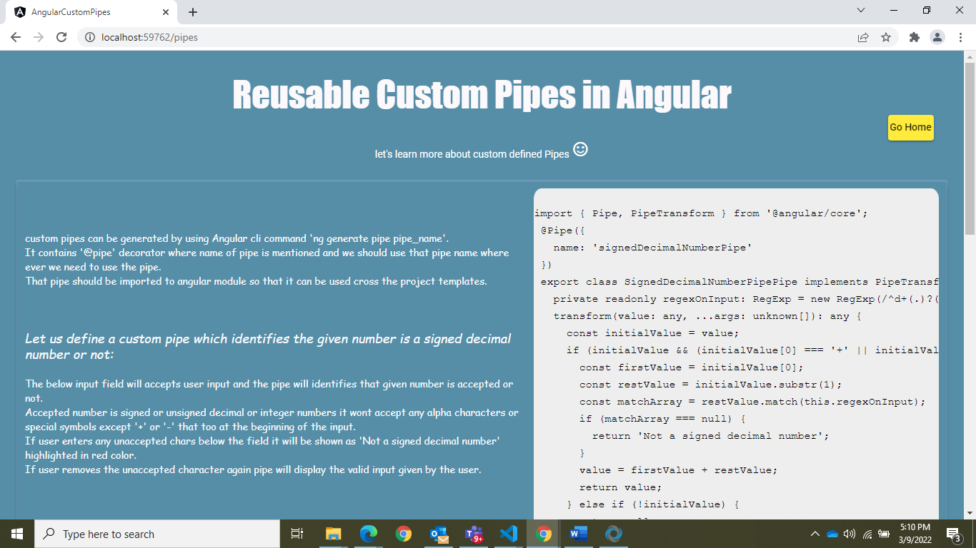

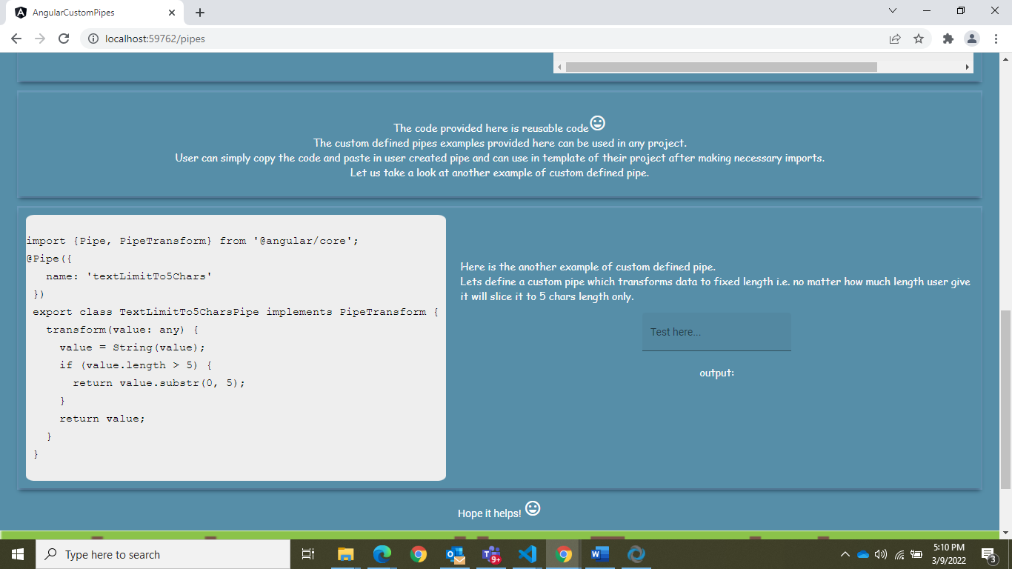

Second page contains two fields which has custom defined pipes are implemented.

User can test and play around with those fields.

**Reusability of the pipes mentioned in this project:**

Suppose user needed a pipe which defines given input as signed or unsigned decimal/integer number, she/he can create a pipe in their project by using command ng generate pipe 'pipe name'.

And can simply paste the pipe code I have provided in the asset and import the pipe in module and use it across the project.

Another example of custom defined pipe is slice the value to it's first five characters Transfers data to fixed length i.e no matter how much length user give it will slice it to first 5 characters.